**Project Report : [HS Assistant]**

At one time people lived in an early age and struggled their lives.

But with the era it has been changing, and what is being understood is by means of science alone. And a common gift of science is artificial intrigue, in which modern people of modern age are advanced and progress towards progress.

Our project is a sample, which can serve as a person's personal assistant. Through this, How to get help from a personal secretary, you can take help as well.

**Features of our Application:**

1. Remember : Anything can be kept in mind, Like as information,

     connotations, and can tell you again.

1. Time & Date : It’s can show Current time and date.
2. Calculation : Can be able to count big arithmetic calculation.
3. BD Dictionary : Words can be transcribed.
4. Conversation : Will be able to interact.
5. I Know some General Knowledge......
6. I can detect Animal........
7. ETC More and more Features……………...…………………..

**Project Demo & Use Procedure:**

**>>Log in Display:**

First, start the program from the **login class**.

After run the program, Sign in will be a platform. Where you need to login with your user name and password.

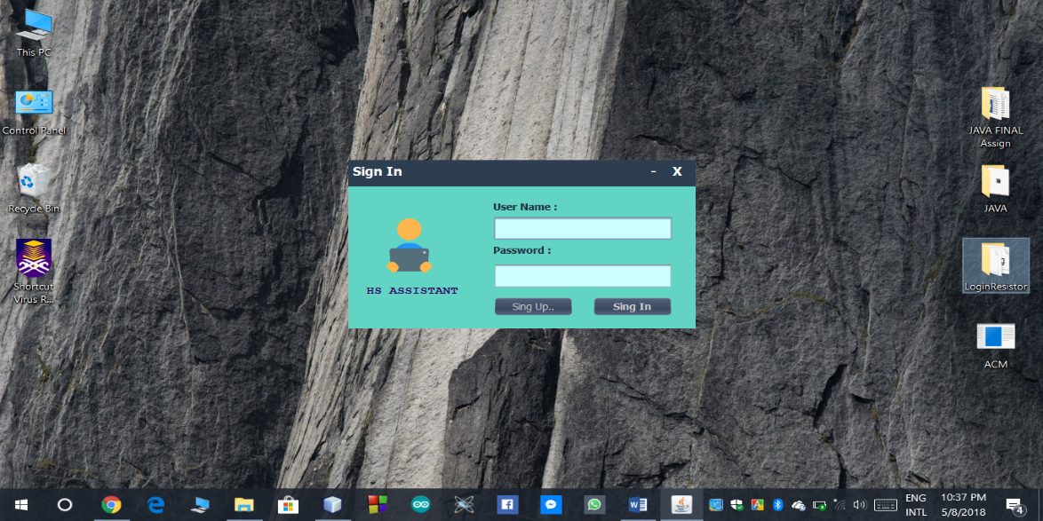

**>>Sign Up display:**

If you do not have an account, click on signup and you will have to click create with all the information. After that you have to login

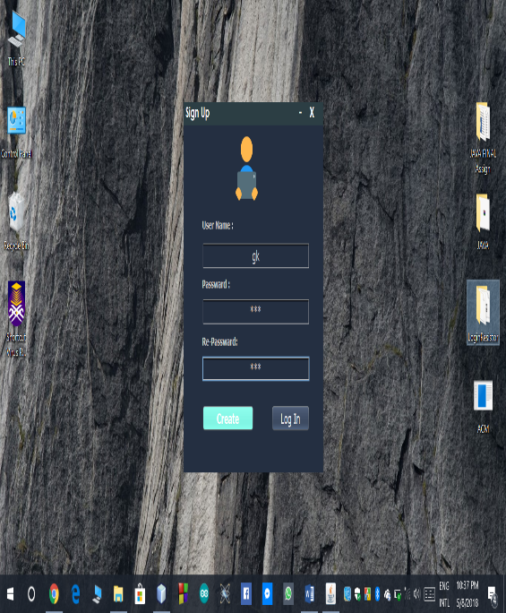  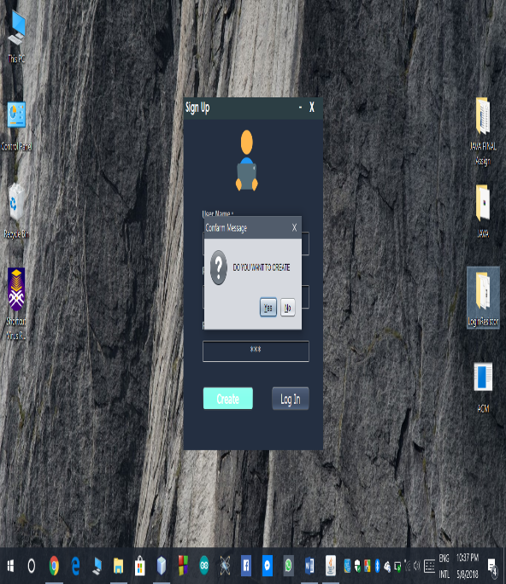

**>>Maid Chat Assistant Display:**

After login , the show main display.

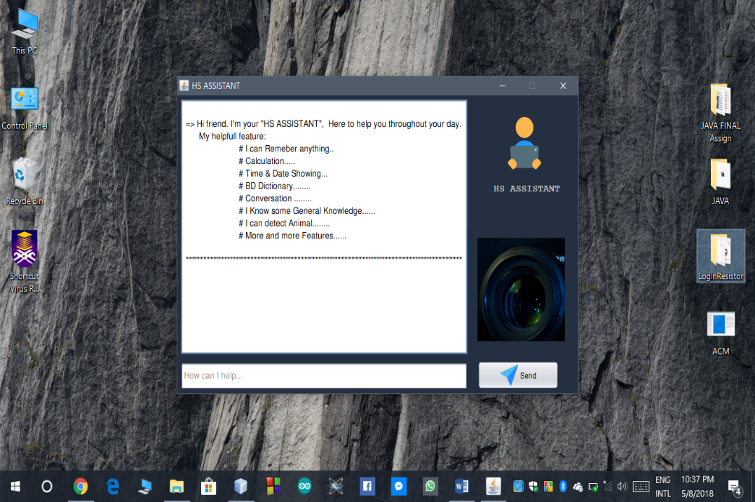

Write “remember=” or “r=” than type anything and click send button.After click button program remember this.

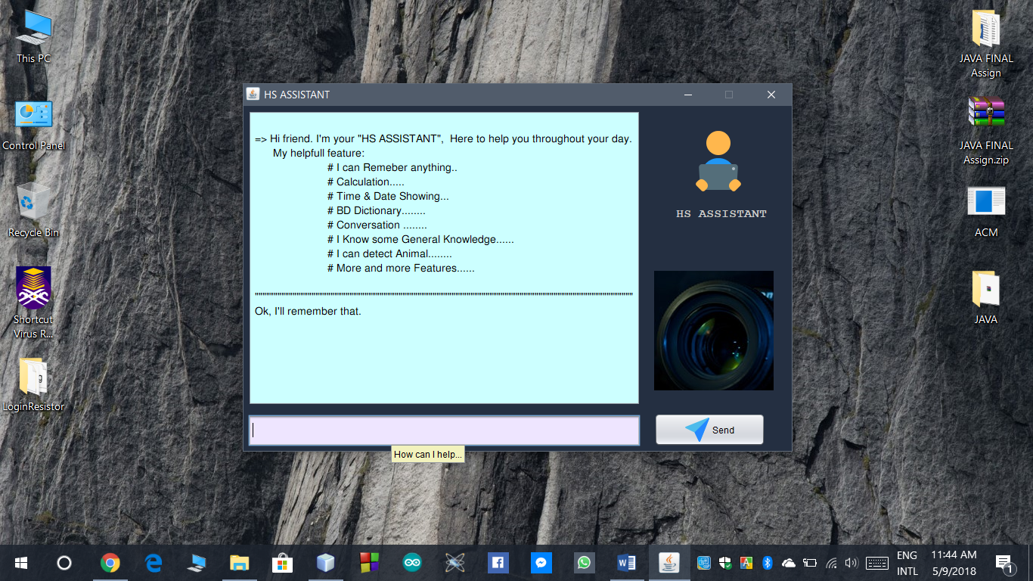

after click send button.then show display “ok remember”

type “rout” or “what i ask you to remember” than show display That's what you have to remember.

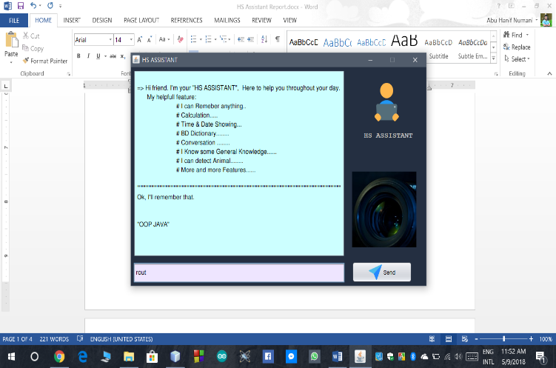

In this way you can take the service using Word, like as

for time and date: “what time is it”,”today date”.

for calculation: “c=” the any string ( 2 + 3 * 4 - 3 ). but must be type spach every character separately.

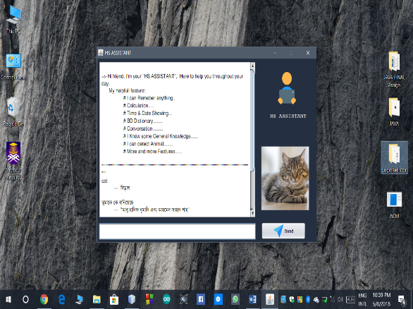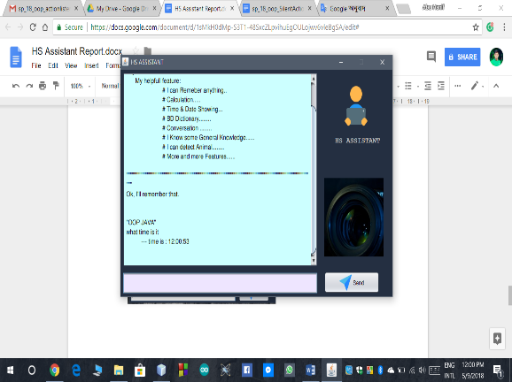

**Building Language:**

**We have created this application using the Java programming language.**

**We hope this Application (HS Assistant) will be useful to many people. And we are developing HS Assistant Day by Day for adding features..**